Exercise 01:
- Explain the difference between static routing and dynamic routing?
Static routing = manual routing (more secure, but not practical for large networks) Dynamic routing = automatic routing (less secure, but practical for large networks)
- Provide the steps involved in static routing
  - Configuring IP addresses for router interfaces (command: ip address IP Mask)
  - Configuring routes manually (command: ip route destination mask interface)
- What are the main families of dynamic routing?
  - Distance vector routing: like RIP and IGRP
  - Link state routing: like OSPF
  - Hybrid routing: like EIGRP
- Explain how each family of dynamic routing operates.
  - Distance vector routing: Each router periodically sends its routing table to all its neighbors.
  - Link state routing: Each router sends its neighbor table to all the routers in the network.
  - Hybrid routing: Exercise for the students.
- How is the configuration of dynamic routing protocols done?
  - Configuration of IP addresses for the router interfaces (command: ip address IP Mask)
  - Activation of the protocol on the routers (example: Command Router RIP)

Exercise 02

Consider the network represented by the figure below, where machine MA wishes to send a datagram to machine MB. Since the two machines are not on the same subnet, the datagram will need to be routed through both routers R1 and R2.

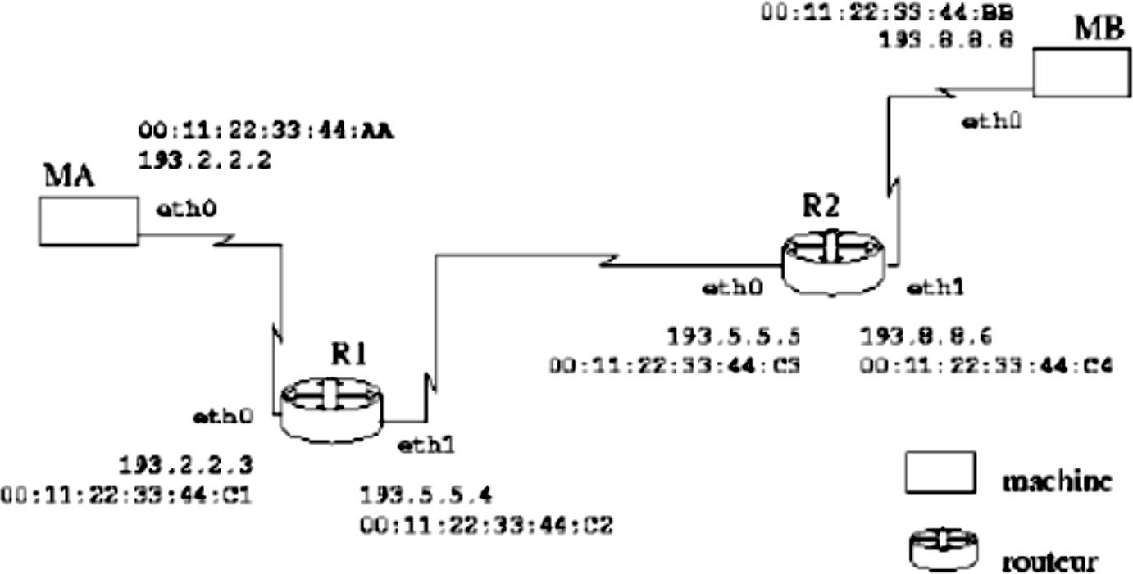

This Internet network is supported by three physical Ethernet networks (3 IP networks) with Internet addresses of class C and a mask of 255.255.255.0, which are 193.2.2.0, 193.5.5.0, and 193.8.8.0.
- Provide the source and destination addresses of the IP packet prepared to be sent from MA.

@IP_src = @IP_MA = 193.2.2.2
@IP_dest = @IP_MB = 193.8.8.8
- Provide the simplest initial routing tables (minimal) on each machine (MA, R1, R2, and MB) to allow the packet to be routed from MA to MB.
The routing table contains the association between:
  - The destination (a machine, a network, or the keyword default for everything else, including what is not explicitly known),
  - The outgoing interface on the current machine
  - And, if applicable, the router through which it must first pass.
  - It is also possible to find the network mask of the destination and a measure of the link cost (which can be expressed in terms of the number of hops, transit time, distance, etc., or a combination of these criteria).
The minimal routing tables are:
MA

Destination | Cost | Mask | Next Hop | Interface
193.2.2.0 | 0 | 255.255.255.0 | - | Eth0
default | - | 0.0.0.0 | 193.2.2.3 | Eth0

MB

Destination | Cost | Mask | Next Hop | Interface
193.8.8.0 | 0 | 255.255.255.0 | - | Eth0
default | - | 0.0.0.0 | 193.8.8.6 | Eth0

R1

Destination | Cost | Mask | Next Hop | Interface
193.2.2.0 | 0 | 255.255.255.0 | - | Eth0
193.5.5.0 | 0 | 255.255.255.0 | - | Eth1
193.8.8.0 | 1 | 255.255.255.0 | 193.5.5.5 | Eth1
R2
Destination | Cost | Mask | Next Hop | Interface
193.5.5.0 | 0 | 255.255.255.0 | - | Eth0
193.8.8.0 | 0 | 255.255.255.0 | - | Eth1
193.2.2.0 | 1 | 255.255.255.0 | 193.5.5.4 | Eth0

- Provide the successive steps necessary for this routing, specifying the addresses used in the Ethernet frame headers sent to carry the above packet.
Assuming that each machine knows the MAC addresses of the machines on its local network (no ARP exchanges). Even if this is not the case, we will omit the address resolution step.
- Machine MA determines if machine MB is on the same network (subnet or LAN) as it is by comparing: @IP_MA && mask and @IP_MB && mask. The result is negative (the two machines are not on the same network, 193.2.2.0 for MA and 193.8.8.0 for MB). MA checks its routing table and concludes that it must pass through its router (R1).
- MA encapsulates the packet destined for MB in a frame sent to R1. We have: @MAC_src = @MAC_MA = 00:11:22:33:44

@MAC_dest = @MAC_R1 = 00:11:22:33:44 @IP_src = @IP_MA = 193.2.2.2
@IP_dest = @IP_MB = 193.8.8.8
- R1 receives the frame and decapsulates the IP packet. It notices that the packet is not intended for it and checks its routing table to determine where to forward it. According to its routing table, the destination network is accessible via its eth1 interface, but it must pass through router R2.
- R1 encapsulates the packet destined for MB in a frame sent to R2. We have: @MAC_src = @MAC_R1 = 00:11:22:33:44
@MAC_dest = @MAC_R2 = 00:11:22:33:44 @IP_src = @IP_MA = 193.2.2.2
@IP_dest = @IP_MB = 193.8.8.8
- R2 receives the frame and decapsulates the IP packet. It notices that the packet is not intended for it and checks its routing table to determine where to forward it. According to its routing table, the destination network is accessible directly (without an intermediary) via its eth1 interface.

Exercise 03
A “show ip route” command applied to a router gives the following result:
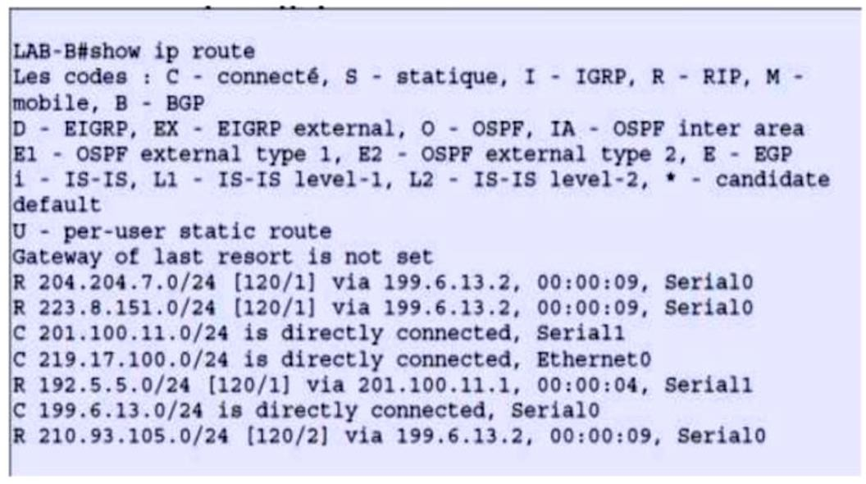
- Provide the topology of the network that you can deduce from this table.

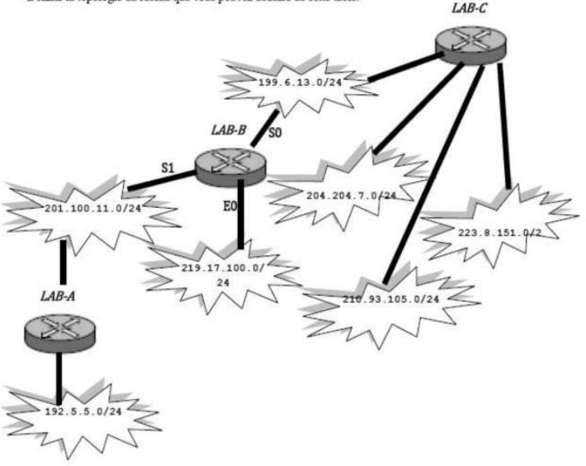

Exercise 04

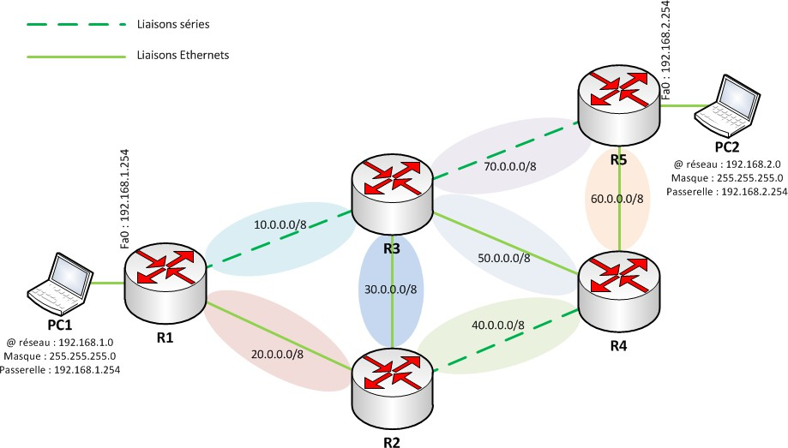Consider the following network.
serial connection
Ethernet connection
Network @ :192.168.2.0
Subnet: 255.255.255.0
Gateway: 192.168.2.254
Network @ :192.168.1.0
Subnet: 255.255.255.0
Gateway: 192.168.1.254

- Fill in the routing tables of the routers using the following methods:
  - Distance Vector
Each router periodically sends its routing table to all its neighbors.
  - Link State
Each router sends its neighbor table to all routers in the network

